Setup minikube at your local and explore creating namespaces (Go through official documentation).

**Step 01:** Install minikube and Setup in Local environment

**Step 02:**  Starting the minikube

**Step 03:**  status of the minikube

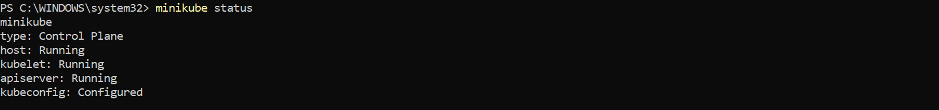

**Step 04:** Checking Dahboard

**Step 05:** Creating Cluster

